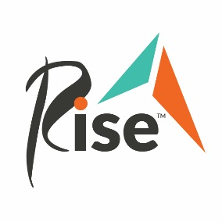
Policy

Policy Name: | External Fundraising

Policy Code: | 214

Policy Purpose: | To establish the parameters in which we accept and work with external fundraisers.

- Overview
Outlined in this document are the guidelines and procedures we ask all external fundraisers to comply with to enable us to successfully uphold our mission and values.

- Procedure

- Introduction:
- Rise accepts all monetary donations. To do a drive for needed items, please contact our Volunteer and Recruitment Coordinator Shannon Widstrom at swidstrom@rise.org.

- All external parties wishing to organize an external fundraiser must complete the External Fundraising Application Form at least 60 days prior to the event date. This form can be found on https://rise.org/.

- Our team will contact the event organizer within 14 days of the request to move forward with the process.

- As event organizer you agree to:

- Ensure the event is accessible to people with disabilities.

- Receive approval of all promotional materials before use. *This approval is additional and is not included in the approval to host the event. Rise may deny the right to use our trademarked logo even if the event is approved.

- Include the following terms in all promotional materials:

  - Name of organizer will donate all/% of the proceeds to Rise to support people with disabilities or other challenges.

  - The Rise name and logo are used with its permission, which in no way constitutes endorsement, express or implied, of any product, service, company, opinion, or political position. The Rise logo is a registered trademark of Rise, Inc.

- Refrain from stating contributions made by participants are tax-deductible.

- Assume all risk for the event’s liabilities and expenses, including obtaining insurance coverage, if necessary.

- Donate the proceeds to Rise within 10 days of the conclusion of the event. Donations can be made in one of two ways:

  - Checks made payable to Rise, Inc. can be mailed to:
Rise
ATTN: Advancement Offices
8406 Sunset Rd. NE
Spring Lake Park, MN 55432

  - Online donations can be submitted through our Online Donation Form.

- As the grateful beneficiary of the proceeds, Rise:

- Will not provide funds, staff, or any promotional material—including social media posts—unless otherwise arranged by the organization.

- Will acknowledge and recognize donations in accordance with our current practices following IRS guidelines for gift acknowledgement.

Disclaimer: Rise reserves the right to decline any external fundraising request.

